

Jeffrey S. Weisswasser, Esquire
Law Office of Jeffrey S. Weisswasser
26211 Central Park Blvd, Suite 504
Southfield, MI 48076

RE: Bartmanski v. Lopiccolo Brothers Foods

Dear Jeffrey S. Weisswasser,

Enclosed please find the Notice of Records Deposition. We are requesting that these facilities release records to us within two (2) weeks. If you have any objection to the copying of the records and documents, please call (877) 886-5090. If you would like to receive copies of these records, please fill out this form at your earliest convenience and return to:

Axiom Requisition Copy Service
2869 Jolly Road
Okemos, MI 48864
Fax (517) 886-4116
records@axiomcopy.com

If you have any questions or comments, please feel free to contact my office. Thank you for your kind attention in this matter.

Sincerely,
Axiom Requisition Copy Service

Zachary Gardner
Zachary Gardner
Account Executive

Enclosure

Order No. 01-31989-001
A Division of The Axiom Group Inc.  2869 Jolly Road  Okemos, MI 48864 | www.AxiomCopy.com | 517.886.5099  Toll Free 877.886.5090  Fax 517.925.5163
STATE OF Michigan

Workers' Compensation AGENCY

Shawn Bartmanski  vs.  Lopiccolo Brothers Foods | )  )  )  )  )  )
NOTICE
TO: Jeffrey S. Weisswasser, Esquire
Law Office of Jeffrey S. Weisswasser
26211 Central Park Blvd, Suite 504
Southfield, MI 48076
PLEASE TAKE NOTICE THAT ON AT THE HOUR OF 9:00 A.M. THE DEPOSITIONS OF:

_______ Stephen Swetech, DO (Medical Records and Films)

will be taken before a Notary Public, or other officer authorized to administer oaths, at 2869 Jolly Road, Okemos, MI 48864, pursuant to provision 2.305 of the Michigan Court Rules. The undersigned counsel does not propose to interrogate the Deponent, the proceedings being solely for the purposes of copying the records and documents in the possession or control of the Deponent. You, of course are welcome to appear if you so desire. A copy of the subpoena(s) are attached. If you have any objection to the copying the records and documents, please call (877) 886-5090.

THERE WILL BE NO INTERROGATION OF THE DEPONENT(S) BY THE UNDERSIGNED COUNSEL.
PLEASE USE THE ATTACHED COPY ORDER OR CALL OUR OFFICE TO ORDER COPIES.

BY: The Hanover Law Group
Michael D. Lask, Esquire ()
25800 Northwestern Hwy Suite 400
Southfield, MI 48075

I, Leah D. Boroski, being first duly sworn on oath, state that a copy of the above Notice was mailed/delivered by the undersigned to the above named this November 8, 2026 |  | Subscribed and sworn before me this November 8, 2026
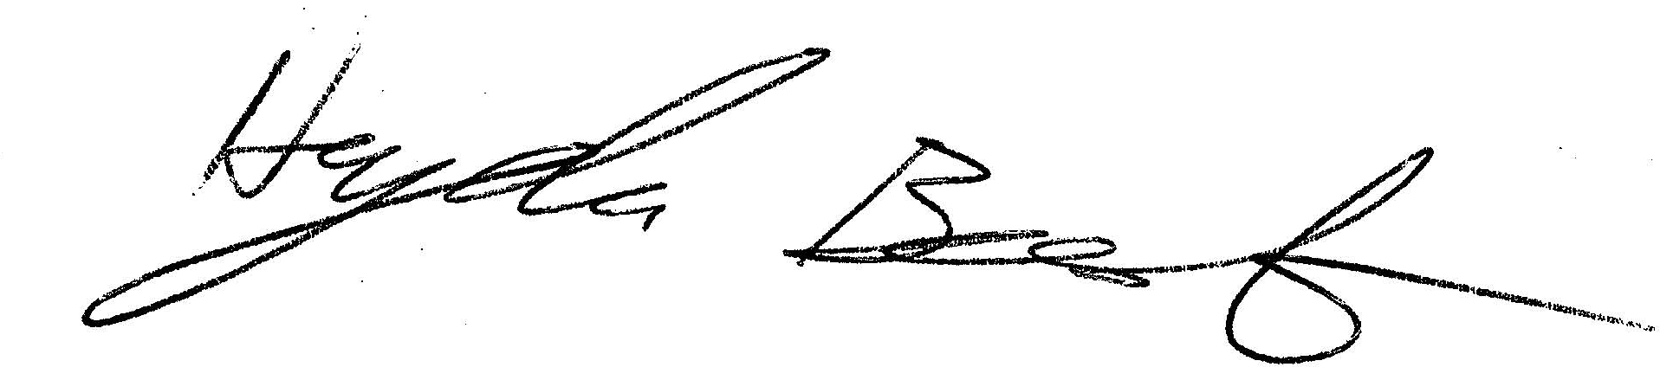  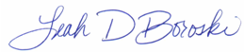 |  | 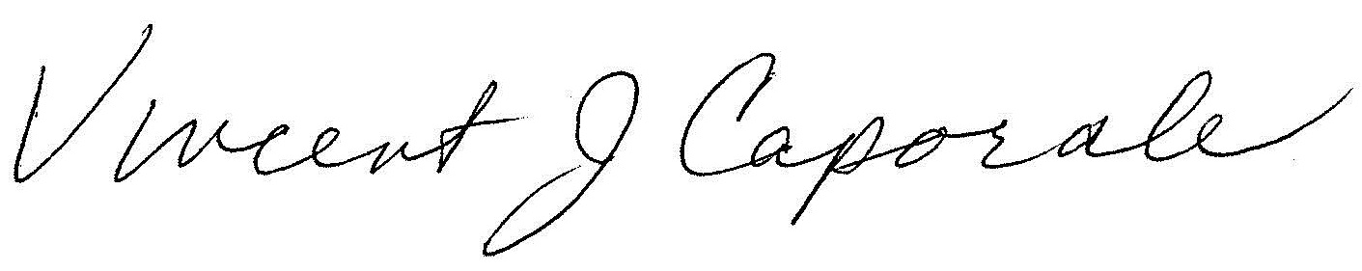
Axiom Requisition Copy Service  2869 Jolly Road  Okemos, MI 48864 |  | Notary Public / Eaton County, Michigan  Acting in Ingham County  My Commission Expires: 03/26/2018

Order No. 01-31989-001 -- Contact: Zachary Gardner

STATE OF Michigan

Workers' Compensation AGENCY

Shawn Bartmanski  vs.  Lopiccolo Brothers Foods | )  )  )  )  )  )
NOTICE
Our client, Michael D. Lask with The Hanover Law Group attorney for the Defendant, has commissioned Axiom Requisition Copy Service to obtain records on Shawn Bartmanski from the following custodian for use in the above referenced case.
IF COPIES ARE DESIRED, PLEASE INDICATE BELOW BY MARKING “Y” OR “N” IN THE SPACE PROVIDED NEXT TO THE CUSTODIAN’S NAME AND MARK YOUR BINDING PREFERENCES BELOW.

_______ Stephen Swetech, DO (Medical Records and Films)

Binding Preferences: □ 2-HOLE / TOP □ 3-HOLE / LEFT □ DIGITAL VIA WEBSITE □ CD-ROM
DIRECT BILL TO: ____________________________________________________________________________
CLAIMS REP: ______________________________________ CLAIM NO.: ______________________________

I agree that I and/or my firm will be responsible for payment of the copies of records ordered on this notice. I acknowledge that invoices are due and payable within 30 days of receipt.

Dated: _________________________ _____________________________________________________
Signed

Jeffrey S. Weisswasser, Esquire (P26039)
Law Office of Jeffrey S. Weisswasser
26211 Central Park Blvd, Suite 504
Southfield, MI 48076
(810) Fax (810)
Attorney for Petitioner

For notification of records available online, please supply your email address: _______________________________________

Please Return To: Axiom Requisition Copy Service
2869 Jolly Road
Okemos, MI 48864
(877) 886-5090 Fax (517) 886-4116
records@axiomcopy.com

NOTE: RETURN OF THIS FORM IS REQUIRED WITHIN TWENTY (20) DAYS TO PROCESS YOUR REQUEST. ANY CANCELLATION OF THE ABOVE MUST BE IN WRITING. IF THE RECORDS HAVE ALREADY BEEN COPIED AND FEES INCURRED, THEN BILLING WILL BE PRORATED ACCORDINGLY.

Order No. 01-31989-001 -- Contact: Zachary Gardner

